Name:
Professor:
Course:
Date:
Jenna No. 2
Part A
Condition | Appearance of the condition | Picture of the condition | Causes | Treatment if any | Reference to a podiatrist or medical professional?
Tinea Pedis | Itchy erosions medium-sized blisters and sole and sides of feet covered by scales. | 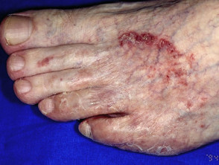  Source: Gupta A. K., and Cooper E. A. Update in antifungal therapy of dermatophytosis. Mycopathologia. 2008; 166 (5-6): 353. DOI: 10.1007/s11046-008-9109-0 | Dermatophyte fungi | Drying of feet, avoid occlusive footwear, barrier protection, and topical antifungal therapy | Medical professional
Tinea Corpis | Enlarged raised red rings with a clearing at the center | 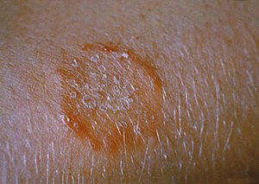  https://en.wikipedia.org/wiki/file:Ringworm-on-the-arm-or-tinea-corporis-due-to-trichophyton-mentagrophytes-PHIL-2938-lores.jpg | Dermatophyte fungi | Topical antifungal creams, terbinafe and naftifine | Medical professional
Blue Nails | Bluish hue of the skin and under the fingernails | 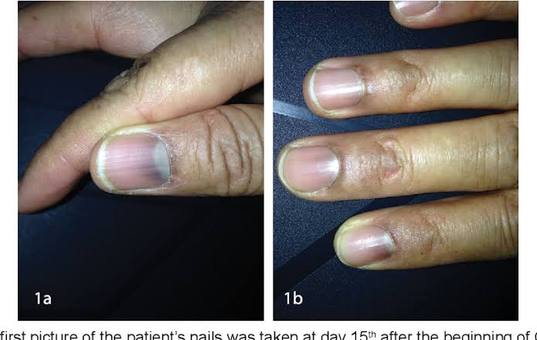  Https://www.semanticscholar.org/paper/blue-fingernails-during-treatment-for-minimal-christiana/6c5626da43d654ded60f378af06b93de5df8c570 | Hypoxemia | Identification of cause and restoration of oxygen level in the blood | Medical professional
Leuconychia | White coloration of the entire nail plate | 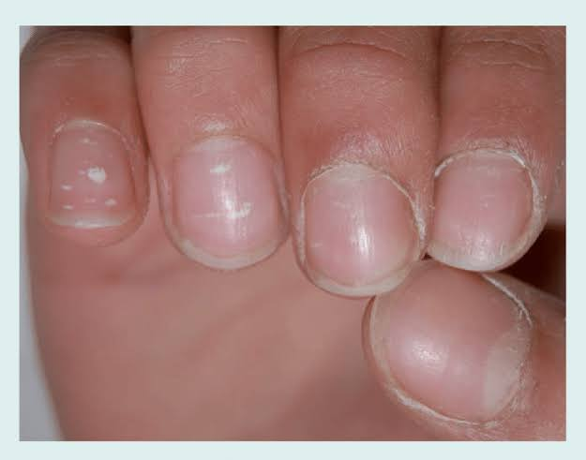  https://www.researchgate.net/figure/punctate-leukonychai-in-the-fingernails-of-an-8-year-o;d-boy-small-white-spots-within-fig12-262795242 | Trauma, poisoning, inherited, infection. | Nail biopsy, mycology | Podiatrist
Beau’s Lines | Indentations across the nails | 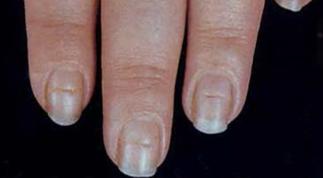  https://www.mayoclinic.org | Diseases that affect nail growth, chemotherapy drugs, fungal infection, toxins, | Treatment of underlying cause of changes in nails. | Medical professional
Pterygium | Triangular shaped growth of tissue on the surface of the eye | 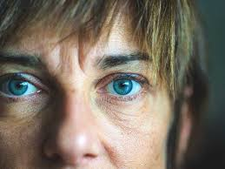  https://www.healthline.com/health/pterygium | Exposure to excess UV light | Medication and surgery | Medical professional
Koilonychia | Nails curve like a spoon | 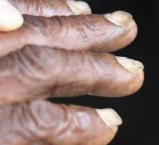  https://www.medicalnewstoday.com/articles/318761.php | Autoimmune conditions, nutritional deficiencies | Treatment depends on the cause | Medical professional
Paronychia | Redness of the skin, blisters filled with pus, change in nail color, shape, and texture, and detachment of nails. | 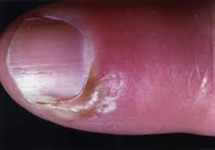  https://www.heealth.harvard.edu/a-to-z/paronychia-a-to-z | Candida | Antifungal treatments, antibiotics | Medical professional
Tina ungium | Thickened, painful, and unsightly nails | 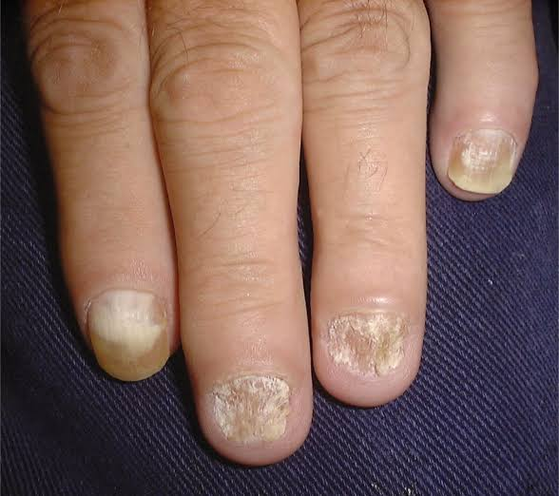  https://www.aafp.org/afp/2013/1201/p762.html | Fungi | Antifungal tablets, nail paint, removal | Medical professional
Onychocryptosis | Ingrown toenail | 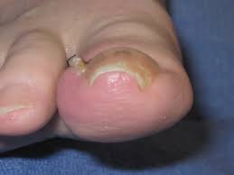  https://www.dermatologyadvisor.com/home/decision-support-in-medicine/dermatology/ingrown-nails-onychocryptosis-ingrown-toenails/ | Improper trimming | Surgical treatment | Medical professional
Calluses | Thick hardened layers of skin | 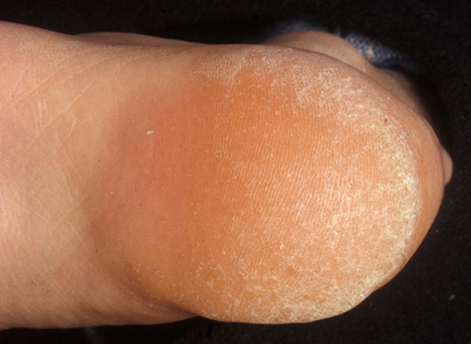  https://www.mayoclinic.org/-/media/kcms.gbs/patient-consumer/images/2013/08/26/10/32/ds00033-im02086-sn7-callusesthu-jpg.jpg | Pressure and friction from repetitive action | Avoiding repetitive action | Podiatrist
Heel fissures | Hard, dry, flaky bottom skin with fissures that are painful and can bleed sometimes | 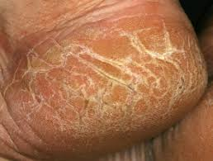  https://dermnetnz.org/topics/cracked-heel/ | Inactive sweat glands, walking barefoot, wearing sandals, living in dry climate, and obesity | Use of pumice stone to decrease the thickness of the layer, moisturizing feet, and wearing closed shoes and sandals with thick soles | Podiatrist
Corrugations/furrows | Vertical ridges in the nails | 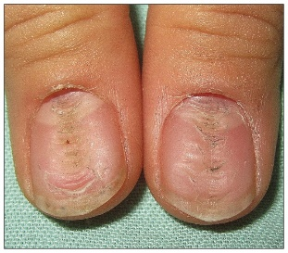  https://ww.medicalnewstoday.com/articles319867.php | Aging, injury, digestive disorders | Based on the underlying cause | Medical professional
Eczema/dermatitis | Red and itchy skin | 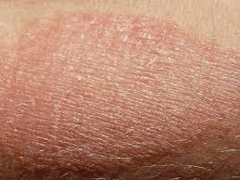  https://www.mayoclinic.org | Food allergies, bacteria, irritants, and allergens | Medications and therapies | Medical professional
Discolored nails | Nails appear white, green, or yellow | 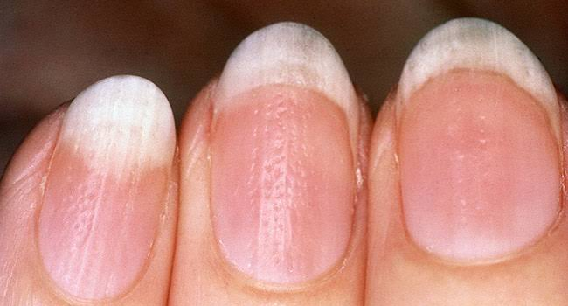  https://www.healthline.com/health/toenail-problems | Bacterial infection, malnutrition, onycholysis, trauma, candidiasis, yellow nail syndrome | Terbinafine, itraconazole, and fluconazole | Podiatrist
Habit tic | The nail folds to the distal edge of the nail | 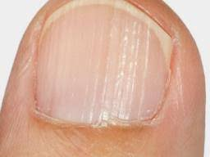  https://www.ncbi.nlm.nih.gov/core/lw/2.0/html/tileshop-pmc/tileshop-pmc-inline.html | External trauma to the nail matrix | Cessation of the external trauma | Podiatrist
Onychotrophia | The nails appear to have wasted away | 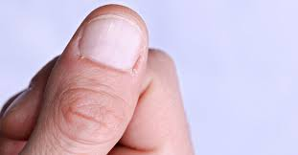  https://www.ncbi.nlm.nih.gov/pmc/articles/PMC3038811/ | Vascular problems, Lyell’s syndrome, skin disease, thyroid, trauma | Treatment of the underlying cause | Medical professional
Splinter hemorrhage | Tiny bloodspots underneath the nail | 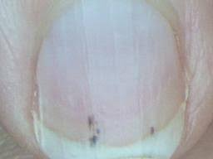  https://www.healthline.com/health/spliner-hemorrhages | Injury of the nail, bacterial endocarditis, vasculitis, systemic diseases, cholesterol, and Raynaud’s disease | Treatment of the underlying cause | Medical professional
Blisters | Raised portion of skin filled with fluid | 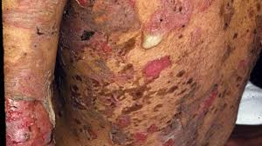  https://www.healthline.com/health/blisters | Burns, allergic eczema, frostbite, stomatitis. | No treatment is required for most of blisters | Podiatrist
Bunions | The bid toe appears to be pointing towards the other toes of the same foot. | 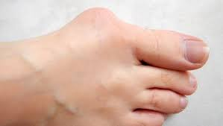  https://www.medicalnewstoday.com/articles/310096.php | Genetic causes, flexible joints, arthritis, gout. | Use of pain killers, bunion pads, orthotics, surgery | Medical professional
Corns | Hardened layers of skin | 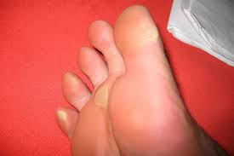  https://www.verywellhealth.com/corns-and-calluses-1337759 | Wearing uncomfortable shoes, walking or standing for long periods | Filing away the corn, applying castor oil | Podiatrist
Eggshell nails | Nails are white, curved over the free edge, and white in color. | 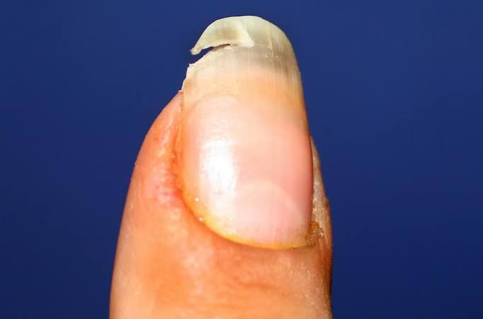  https://www.medicalnewstoday.com/articles/322735.php | Nervous disorders, medication, improper diet, and internal diseases | Treating the underlying condition | Medical professional
Hammer toes | Abnormal bend in the middle joint | 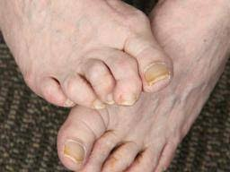  https://www.medicalnewstoday.com/artcles/315600.php | Genetics, toe length, age, injuries, sex, high heels, and thin shoes. | Exercising, stretching the toe, surgery | Medical professional
Hangnails | A piece of skin that hangs near the root of the nail | 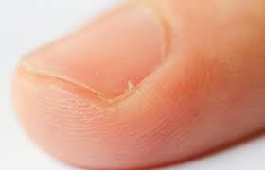  https://www.healthline.com/health/infected-hangnail | Frequent exposure to water and weather | Mostly heal on their own | Podiatrist
Onychauxis | Nails are abnormally thick | 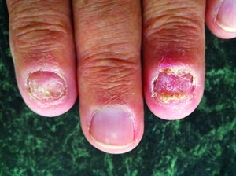  https://www.healthline.com/health/onychauxis | Hereditary causes, psoriasis, acute and chronic trauma, infection, diabetes, | Removal of affected nail, treatment of underlying conditions, proper nail trimming, wear comfortable shoes, nail polish | Medical professional
Onychophagy | Biting of the nails | 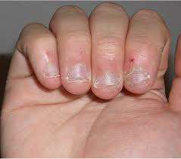  https://www.healthline.com/health/onychophagy | Severe biting of nails | Behavior modification, topical treatments, application of nail polish | Medical professional or a podiatrist depending on severity
Onychorrhexis | Vertical ridges form on the fingernails | 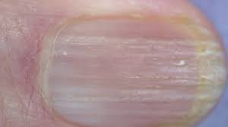  https://www.healthline.com/health/onychorrhexis | Trauma, rheumatoid arthritis, psoriasis, eczema, anemia, eating disorders, amyloidosis. | Treatment of the underlying cause | Medical professional
Brittle nails | Splitting, breaking, and peeling of nails | 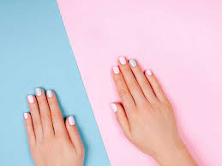  https://www.healthline.com/health/brittle-nails | Lack of enough moisture, old age, lack of iron, Raynaud’s sydmrome | Care for nails, use moisturizer, protect hands | Podiatrist

Part B
Condition | Why the treatment cannot be performed | Reference (medical professional or podiatrist)
Allergic reactions | Because most of nail enamel components used contain potential allergens | Medical professional
Diabetics | Because of increased sensitivity | Podiatrist
Loss of tactile sensation | Because of lack of sensitivity to changes in pressure against the skin | Podiatrist
Bruising or swelling | Because they can be a result of bacterial infection | Medical professional
Recent operations | These treatments can lead to poor healing | Medical professional
Cuts and abrasions | To ensure that chemicals do not enter the body | Podiatrist

